Agrupamento de Escolas Rafael Bordalo Pinheiro
Prof. Alexandra Sampaio
Learning guide

English

Year 10

If-Clauses

Le Ballon by Imprimeur E. Pichot. Original from Library of Congress. Digitally enhanced by rawpixel. Domínio Público
Learning guide

IF-CLAUSES

Learn and practise on your own - being able to express condition in different situations

Learning goal
Learn how to use the website British Council Learning Teens as a tool on a self-learning process focused on the grammatical issue of If-clauses.

Introduction
D
uring this week you will have the chance to get acquainted with the British Council Learning Teens webpage, as a tool which will help practise your English on an autonomous way.
This week we will focus on the If clauses.

Learning activities
1
Watch the tutorial on the British Council Learning Teens webpage and to the excerpts of the songs to recognise the several if clause types:
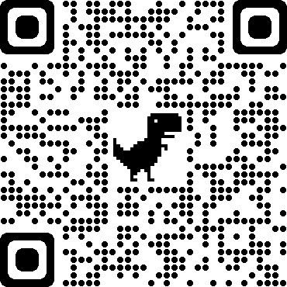
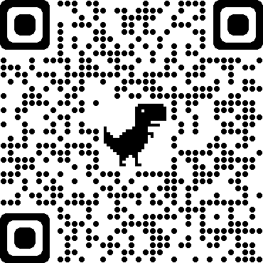

Question 1
Identify the different If clause types in the video and write it down in the Google Classroom assignment – If clauses.

Question 2
Solve the exercises suggested and check your answers, use the British Council Learning Teens page.
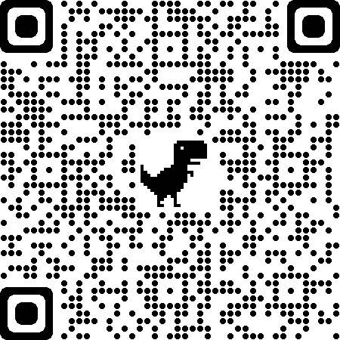

Question 3
Go to page 55 of your textbook A taste for English, and solve the exercises, sending it to the Google Classroom assignment – If clauses.

Travel diary
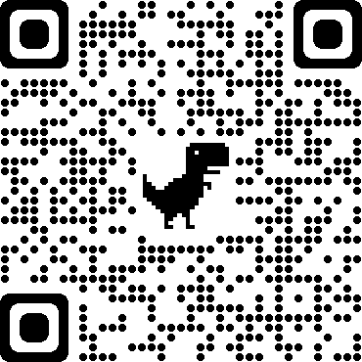
Write a page of a travel diary using If clauses and based on the week you are away from school. Check the following suggestion for building a Travel Diary. But you just have to share a page with us, on Google Classroom.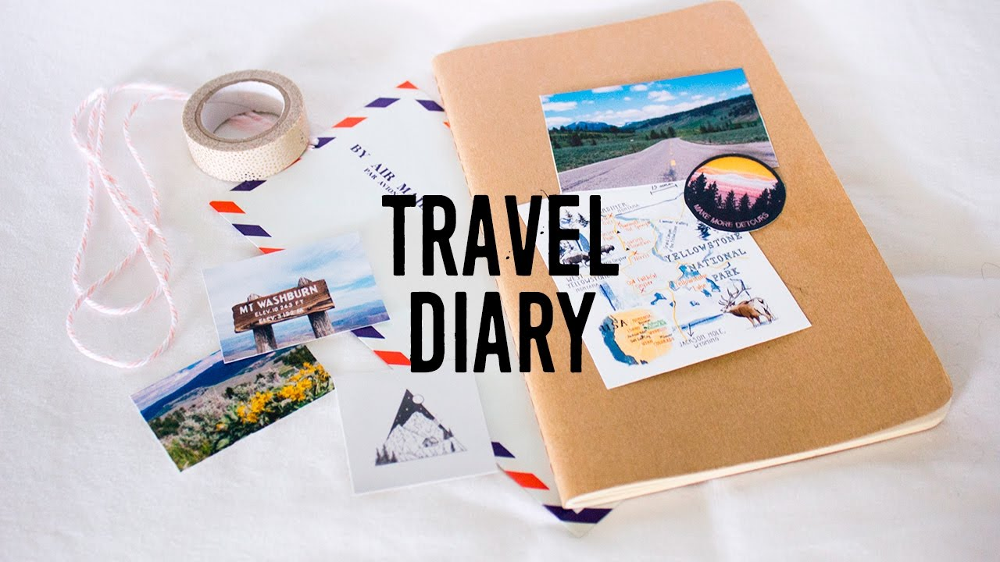

References
Sampaio, A., Mateus, A., Botas, A., & Jales, M.P. (2013). A Taste 4 English. Leya. Acedido em: 27 de maio de 2020 em: https://www.escolavirtual.pt/e-manuais/html5-reader/cloud-reader/kitaboo-reflowable.html#/main/https;%7C%7Cwww.escolavirtual.pt%7Cemanuais-cs%7C9789897441585-TE-01%7Chtml5%7C9789897441585-TE-01-lite%7C?bat=dt3S6hRW9QW8%2FGAWrkL4HasWPOUoCuAeZ53uQCcm0QRsVgYkdXOJ8SSUgI3zFukn&readerType=new&pageMode=double&page=54&menu=thumbnail
British Council. (n.d.). Welcome to LearnEnglish Teens. Acedido em: 10 de maio de 2020 em: https://learnenglishteens.britishcouncil.org/
Salgado, K. (2017). Conditional songs. Acedido em: 20 de maio de 2020 em: https://www.youtube.com/watch?v=A7Od1Wf_XU8

